Evaluation

Contents

Creation of the product 2

Finished product 3

Evidence user details 4

Evidence for Extra’s 5

Evidence for pond measurements 6

Results from pond measurements 7

Printing 8

Testing 9

Limitations 9

# Creation of the product

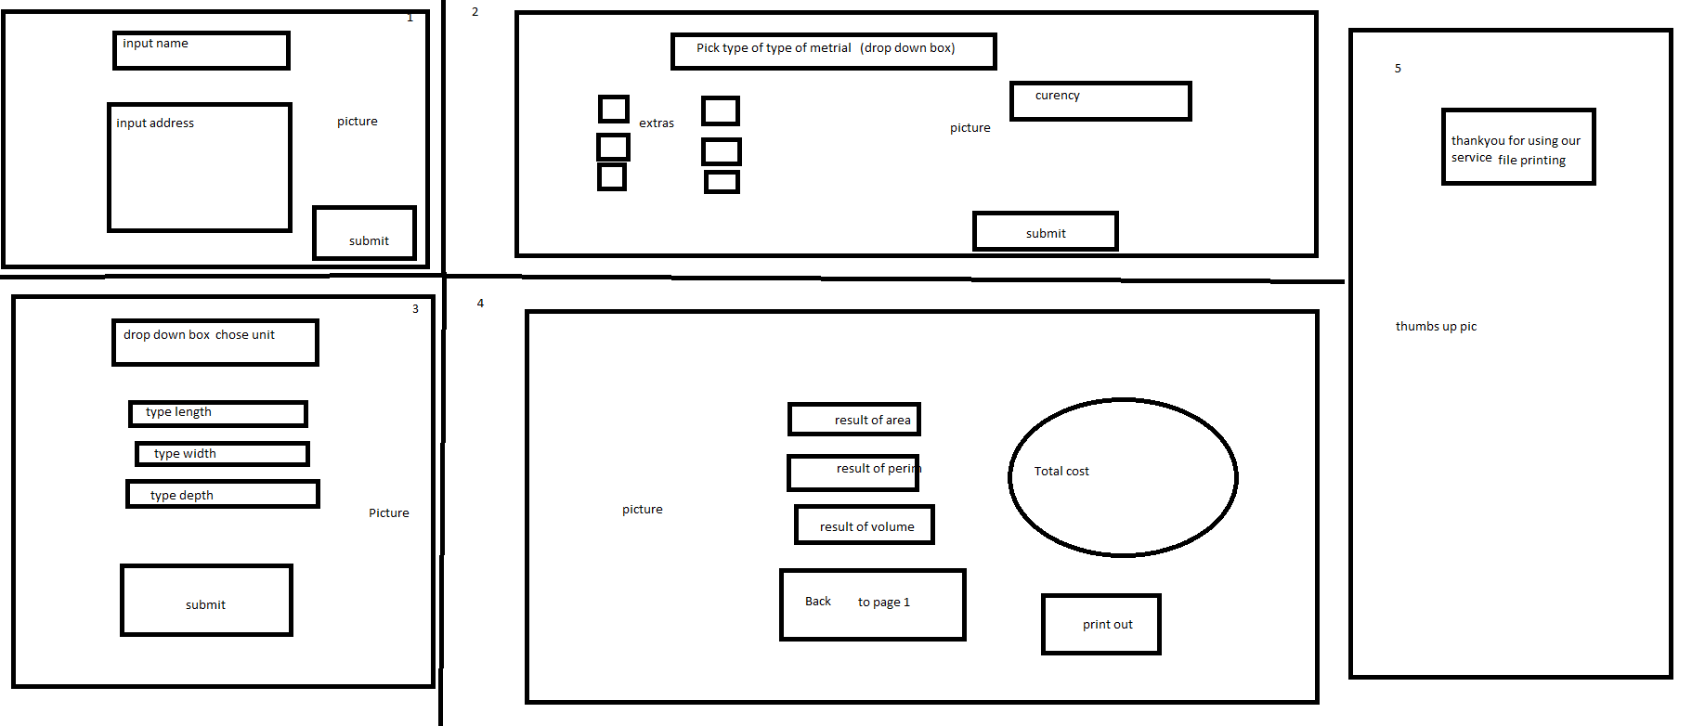I set out to create a functioning pond calculator that was created with C# that can determine the volume, area and perimeter of a pond that can also calculate the cost of labor for creating the pond with the ability to save and load current requests from a customer here is a screenshot of my draft plan.

As you can see it shows that I am intending to show the user a step by step process instead of overloading the user with too much information to be inputted reducing the risk of error.

## Finished product

I have created a very in-depth program that can calculate the cost of labor, determine the volume, area and perimeter of a pond I have also added extra features.

such as

* The ability to covert measurements from meters to centimeters, feet and inches.
* The ability to print out information stored on the program
* The prevention of progressing through the program if a set of information was incorrect such as no first name
* An extra feature’s check box with different options like a filter, different types of fish and different types of plants
* A Navigation option through the program that allows progression depending on previous input such as if there is a first name / last name and address the user can progress to page 2

## Evidence user details

These screenshots show the possess of the program with the code displayed below (not for the users to see)

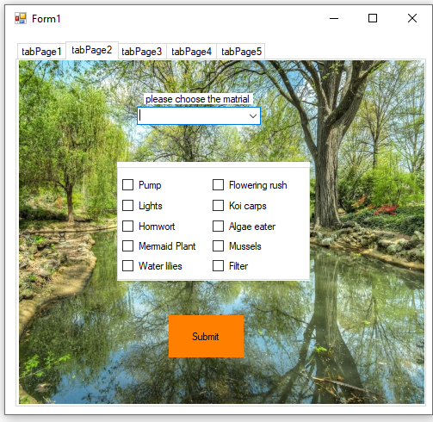

## Evidence for Extra’s

## Evidence for pond measurements

## Results from pond measurements

## Printing

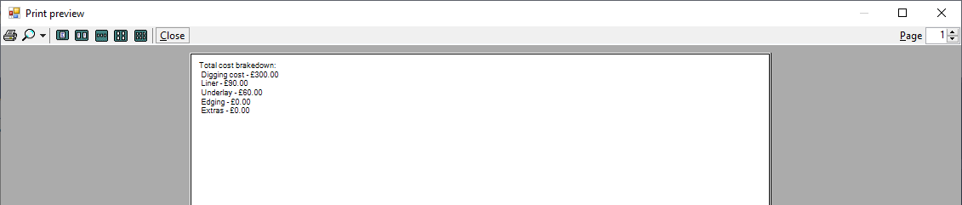

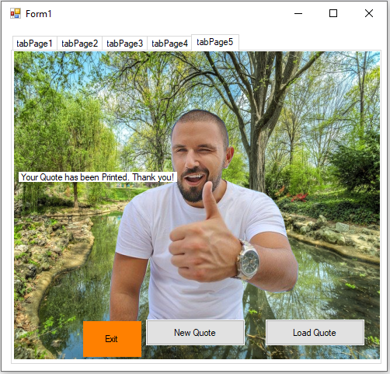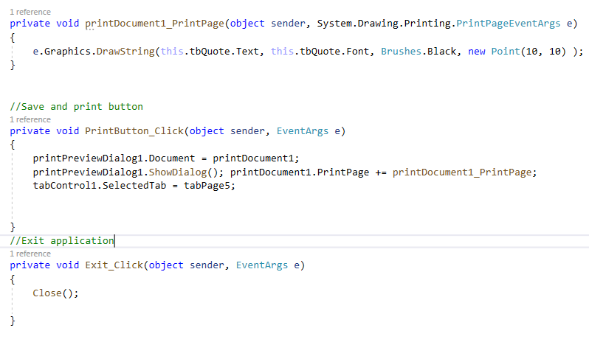

# Testing

I have asked multiple individuals with different skill levels and knowledge of computing to input information like they were requesting a pond to be built for them selecting different options such as making the length 1111111111111111111111111111111111, to see if it would crash or prevent progression, not selecting a conversion like meters for example but I had added a feature that if not selected it will automatically convert to meters I also added validation that if the length, width or depth is less than 1 or more than 20 it will not progress.

# Limitations

While creating the program I had a few issues with features I wanted to add to the program I wanted to add a fade-in and fade-out image at the end of the program but it was possible due to efficiency and was not required, In the future I would like to make the program web-based where it can store the information online and remove orders older than a month saving storage space.